Episode 1
David Carter, who was a 39-year-old father was reported missing in late September of 2018 and later found dead and dismembered. His girlfriend at the time, Tammy Williams, was called in for questioning days after his disappearance, however she was released from custody.
Tamera (Tammy) Renee Williams is the most wanted woman within the US Marshals and her apprehension is the highest priority.


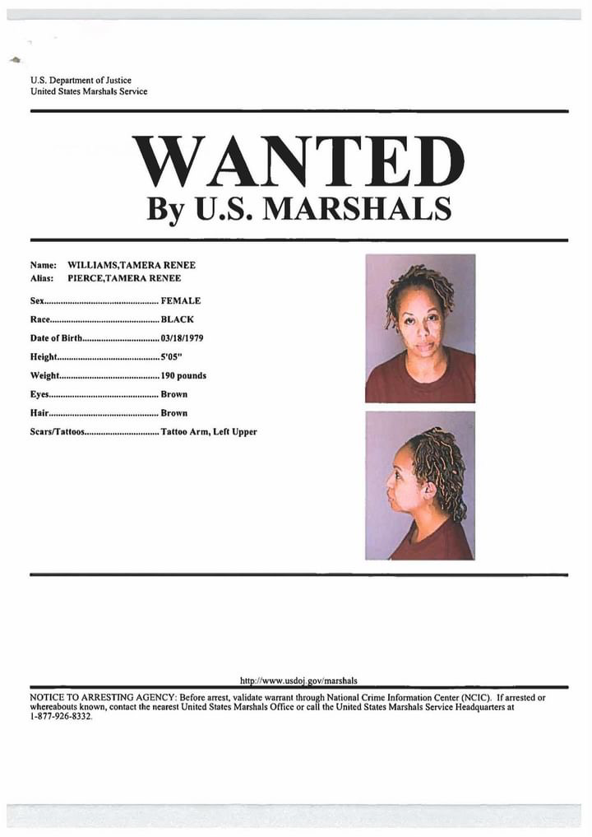

David Carter – Victim
Tamera Williams – Wanted Suspect
DJ Carter – Son of David Carter
Samia Conner – Mother of David Carter
Elton Carter – Father of David Carter
Tasia Carter-Jackson – Sister of David Carter

Timeline of events:
- 9/28/2018
David Carter was last seen attending his son DJ’s Friday night football game. He went to the game with Tammy Williams and they sat separately until David was joined by his sister, Tasia Carter-Jackson and DJ’s mother, Samia Conner.
Tasia believed David and Tammy had previously been arguing and based on the conversation that night with her brother he was tired of Tammy being possessive and ended the relationship after the game.

- 09/29/2018
Tasia believes that Tammy entered David’s apartment after he went to sleep the following Saturday night. This theory has not been confirmed by the investigators. It was known that Tammy has had access to a key to David’s apartment giving her access at times.

- 09/30/2018
David’s mother, Samia Carter and son DJ Carter received texts from David’s phone on Sunday saying that he was sick and DJ should not come to his home for a visit that was planned. DJ Carter decided to stop by his father’s apartment since David never contacted him by phone. He spied on Tammy taking out the trash. When Tammy saw DJ she ran past him to the apartment and locked the door. Later she did let DJ into the apartment but would not allow him into the bedroom or the bathroom. She told DJ that David went for a walk which he considered odd since his father had reported he was ill and did not speak to him on the phone.

- 10/1/2018
A mowing crew with the Ohio Department of Transportation discovered an odd shaped sleeping bag off of I-75 approximately 50 miles from the state border. The troopers determined the bag contained an adult male with a severed lower torso. The Lucas County Coroner indicated the only clue to the man’s identity at the time was a tattoo of a red-eyed pit bull on his upper left leg.

- 10/2/2018
A friend and co-worker of David Carter, contacted Tasia-Carter-Jackson after discovering he did not show up at work for 3 days. Tasia Carter-Jackson and her husband Derrick Jackson went to David’s apartment and found it unlocked. David’s father, Elton Jackson and mother Samia Conner were contacted and the family searched the apartment together and discovered a blood-stained hole at the top of David’s mattress and what appeared to be blood stains under the bed. Jackson, a former soldier, discovered a similar hole in the door to David’s closet and it was recognized as a bullet hole. The Melvindale police were notified and David was declared missing.

- 10/3/2018
Melvindale police contacted Elton Carter a day after David Carter was reported missing. He questioned if his son had any tattoos and informed him of the torso discovered in Ohio. With Elton’s confirmation that David had a tattoo of a red-eyed pit bull on his upper left leg the missing person case was officially a homicide investigation.

- 10/5/2018
Tammy Williams became the prime suspect in David’s murder based on her behavior and lack of concern over David’s disappearance when the family asked her help with the search. Tammy was brought in for questioning while the family learned of the arrest while at DJ’s football game.
DJ’s team won the game and he credited his performance that night to his father’s spirit.

- 10/8/2018
Tammy was released from police custody from police three days after the initial arrest which was the maximum amount of time she could be held without criminal chargers being filed under Michigan law. According to the US Marshals task force in Detroit, there was not enough evidence at the time to press charges against Williams, although she was still a person of interest in this case.

- 10/10/2018
Ten days after the sleeping bag containing David’s lower torso was found, a second bag was found along I-75 in Ohio, north of the first drop site. It was a black duffel bag with red straps that contained David’s head wrapped in several grocery bags. The Lucas County Coroner indicated David died from a single gunshot wound below his left ear.

10/16/2018
Six days later, David’s upper torsi was found again inside a bag on the side of I-75 in Ohio. On the same day, Tammy Williams was seen in Ann Arbor, Michigan. Credit card receipts from that day revealed she made several large cash withdrawals. That evening she was spotted eating alone in a local restaurant and spent the night in a local hotel.

- 10/18/2018
According to a male, Tammy Williams was last seen two days after David’s upper torso was located. She traveled by train from Ann Arbor to Chicago before doubling back and traveling to New York City. She was seen leaving the Neptune Hotel in NYC on 10/18/2018. Now her current whereabouts are unknown.

