Episode 6
Da’Jour Russ, 22-year-old was working for Door Dash to make ends meet gunned down in CorkTown and the shooting happened at Clement Kern Gardens apartments.



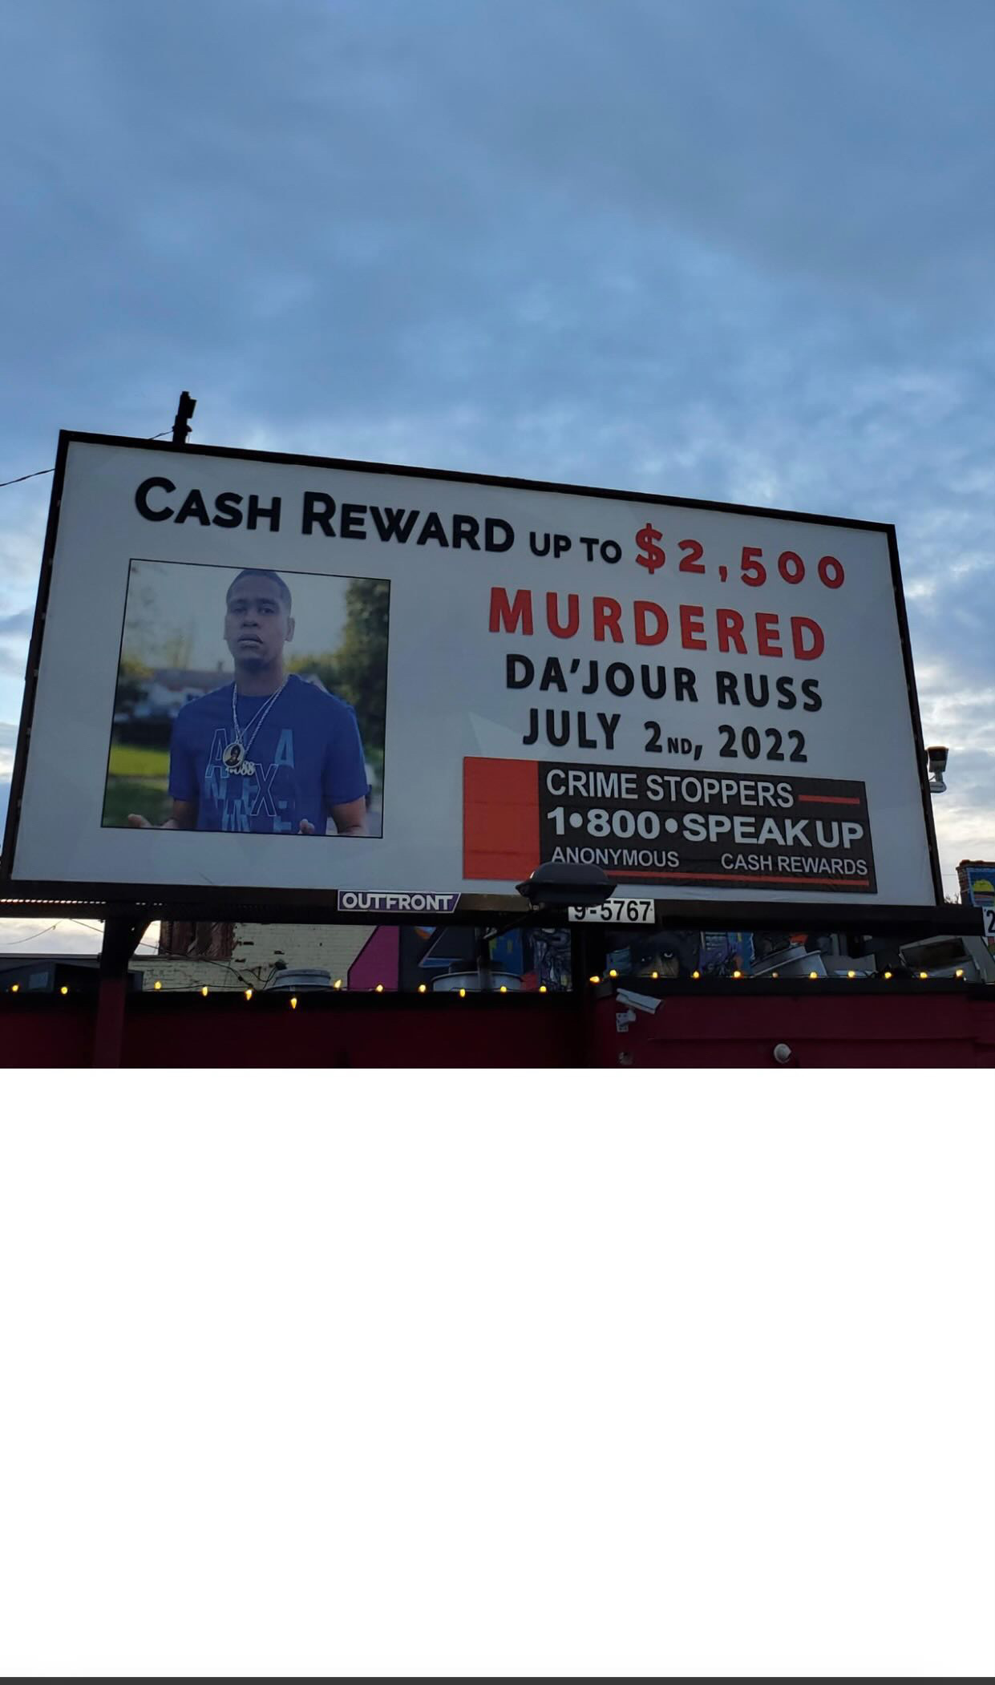

Da’jour Russ - Victim
Tolanda Russ – Mother
James Jackson (Jack Funny) - Uncle

Timeline of events:
- 7/4/2022
Da’jour was on his first day working as a DoorDash delivery Driver. He exited his vehicle to drop off food when a suspect in an unknown vehicle fired shots at him, hitting him in the foot. The vehicle then circled back around and fired more shots, this time fatally wounding him.
The shooting happened around 8 pm on July 2nd in the 1700 block of Bagley. Police said Da’jour was accompanied by another family member for his first day on the job when he stopped at a home.

Dajour Russ | Detective Jordan  313-675-7000 | Tolanda Russ (Mother) - 313-588-5162

