Episode 2
Bryon Gilbert, a.k.a DJ Slick B, was killed during a robbery in 2020.
Two gunmen robbed the DJ on W. McNichols and his friend was shot with a non-fatal injury at Ilene Street on Detroit's west side around 7:30 p.m. Feb. 7, 2020.

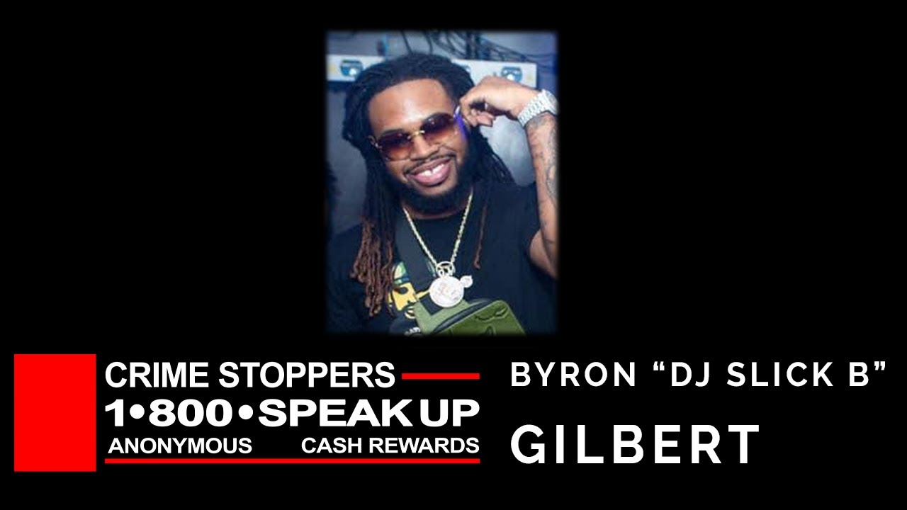

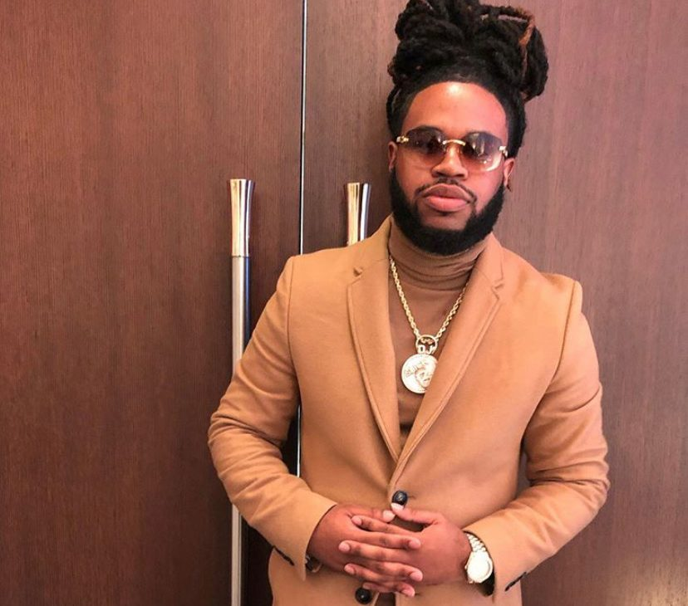

Byron Gilbert AKA DJ Slick B, 28 – Victim (Fatally wounded)
Friend, 25 – Victim (Shot – Non-fatal injury)

Timeline of events:
- 2/7/2020
Bryon Gilbert, a.k.a DJ Slick B was popular and widely known in the Metro Detroit area and was killed after attending an event where he performed. The two suspects waited for Gilbert and his friend where surveillance video shows the moments leading up to the killing. Police believe the two suspects emerged from inside the vehicle and fired shots. Gilbert was fatally wounded and his friend suffered a non-fatal injury. The suspects left in a dark colored SUV with covered plates.
Even though the killers took Gilbert’s phone and a chain, police say robbery was not the motive in this premeditated murder.

- 2/9/2020
A benefit concert was held for Gilbert ay Club Annex. The friends and family of the beloved Metro Detroit DJ gathered to remember him the best way they could -- through music.
All donations will be given to the family of DJ Slick B.
Club Annex Detroit 2020 RIP DJ Slick B (youtube.com)

