Episode 4
The 2003 murder of an employee during a robbery at a Hungry Howie's in Detroit is still unsolved. Brion Barrett was working at the restaurant on W. McNichols near the Southfield Freeway on Feb. 25, 2003, when two armed robbers came in and killed him around 11 p.m.
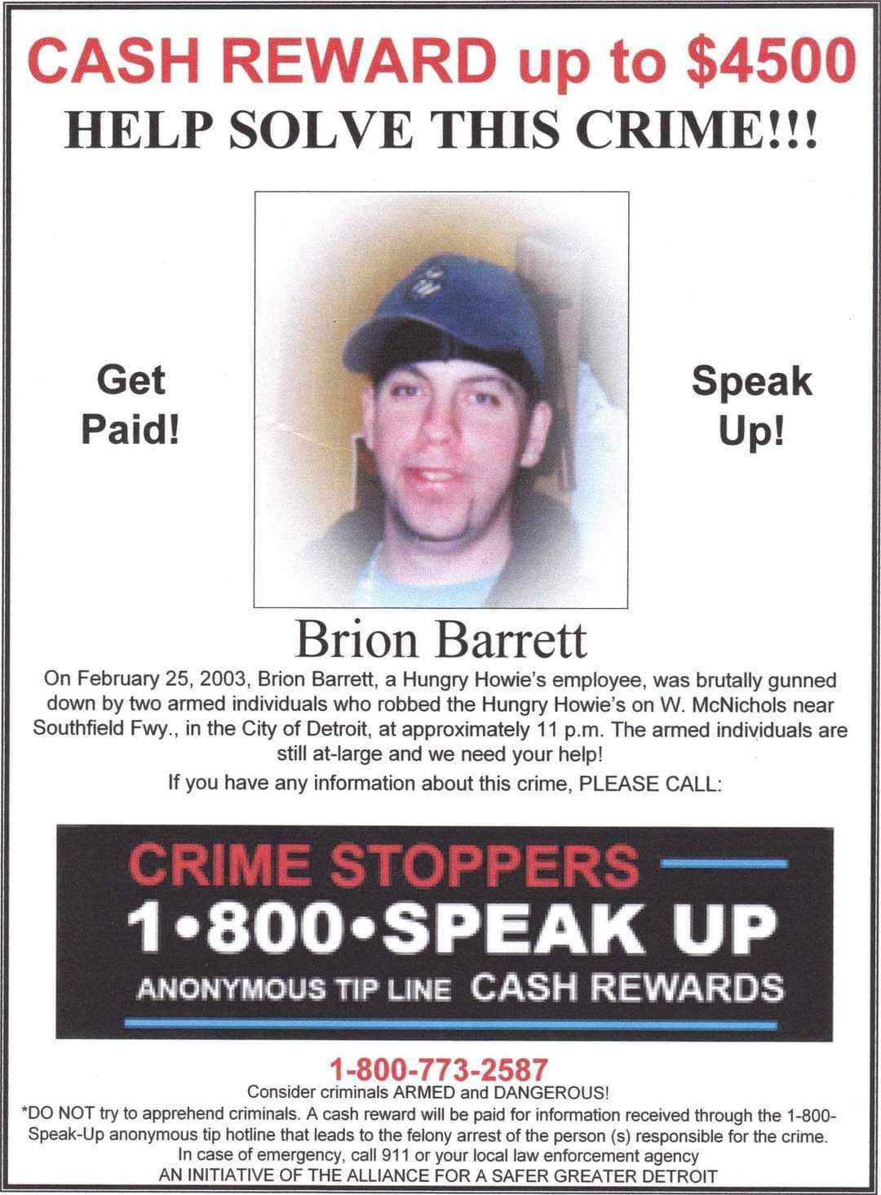

Brion Barrett, 28 – Victim (Fatally wounded)
Manager of Hungry Howie’s
4 employees of Hungry Howie’s

Timeline of events:
- 2/25/2003
Approximately 11:45 PM, just before Hungry Howie’s was closing, two gunmen followed Barett inside the first door at the store. A gun was held to his head until they buzzed them into the second door.
One of the two robbers held a gun on Barrett, the other hit the manager in the head with a gun who was behind the security glass with three other employees, and was forced to open the security door.
When the manager complied, the gunmen forced all the employees in the back room. The five employees were forced to lie on the floor and the gunmen robbed them and the store of about $1,200 in cash. One of the employees indicated they had guns on him and his head.
Barrett, who had worked at the store for five years, told the men they did not have to hurt anyone.
One of the gunmen then shot Barrett in the head.
The gunmen, who employees estimated to be in their twenties, are still at large.

- 2/26/2003
Barrett died the morning of 2/26/2003 at Botsford General Hospital in Farmington Hills.

